EXPLORATORY DATA ANALYSIS REPORT

Dataset: StudentsPerformance 1.csv
Date: 28.01.2026
Analyst: Toleubek Assiya
- What's the average math score by gender?
- Is there correlation between reading and writing scores?
- Do test preparation courses help?
- Which parental education level gives best results?
- What's the score distribution by lunch type?
1. EXECUTIVE SUMMARY
• Dataset contains 1000 records with 8 features
• Key finding 1: Gender differences exist in academic performance: males perform better in math, while females outperform males in reading and writing.
• Key finding 2: Strong relationships are observed between subjects, especially between reading and writing scores.
• Key finding 3: Test preparation courses have a positive impact on student performance across all subjects.

2. DATA QUALITY
• Missing values: [0] - No missing values
• Data types: int64(3), object(5)
• Outliers: Outliers were identified using boxplots but retained as valid observations since they represent real student performance.
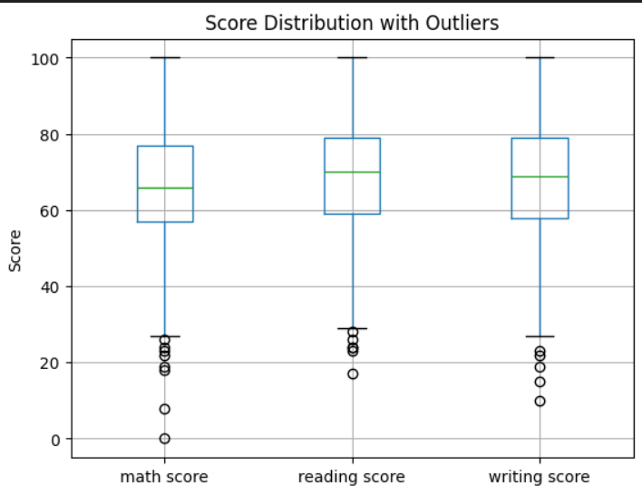

3. KEY INSIGHTS
• Insight 1 with supporting evidence: Male students perform better in math: (68.7 > 63.6), whereas female students achieve higher scores in reading (72.6 > 65.5) and writing (72.5 > 63.3):
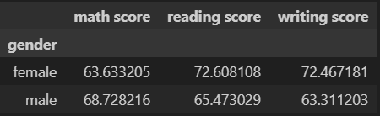

• Insight 2 with supporting evidence: Student performance shows strong positive correlations between math, reading, and writing scores:
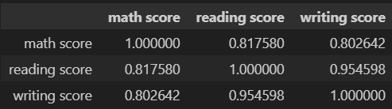
The strongest relationship is observed between reading and writing scores 0.95, who perform well in reading almost always perform well in writing

• Insight 3 with supporting evidence: Students who completed test preparation courses achieved higher average scores across all subjects:
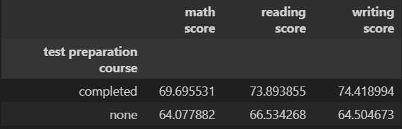
On average, their math score was 69.7 vs 64.1 for students without preparation.
In reading, prepared students scored 73.9 vs 66.5, and in writing 74.4 vs 64.5.

4. VISUALIZATION SUMMARY
• Chart 1: Correlation heatmap showing strong relationships between math, reading, and writing scores
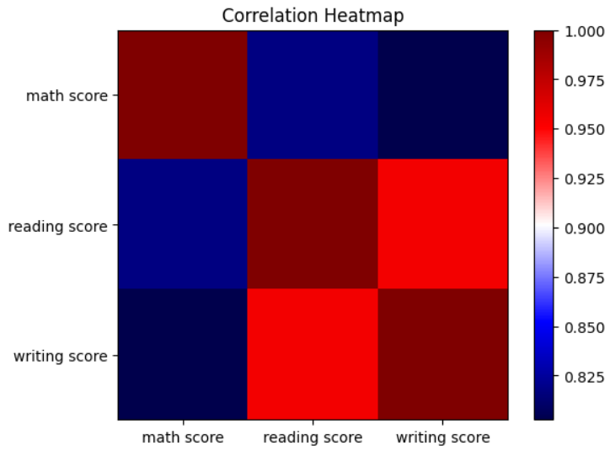

• Chart 2: Boxplot illustrating score distributions by gender across all subjects.
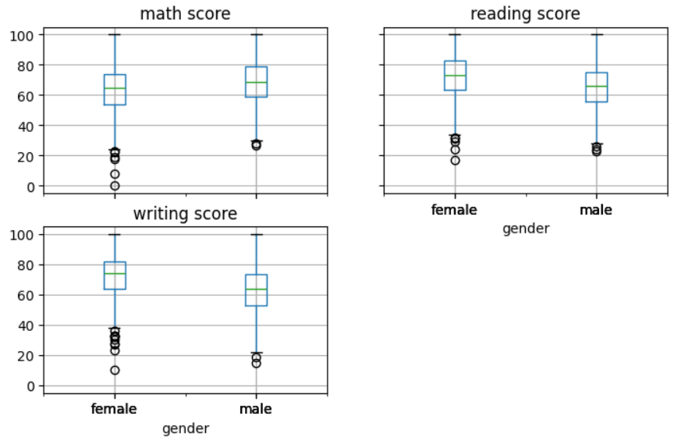

• Chart 3: Shows the distribution of student scores in math, reading, and writing
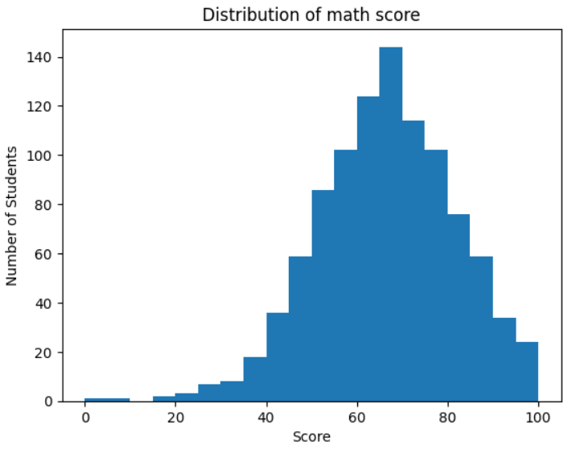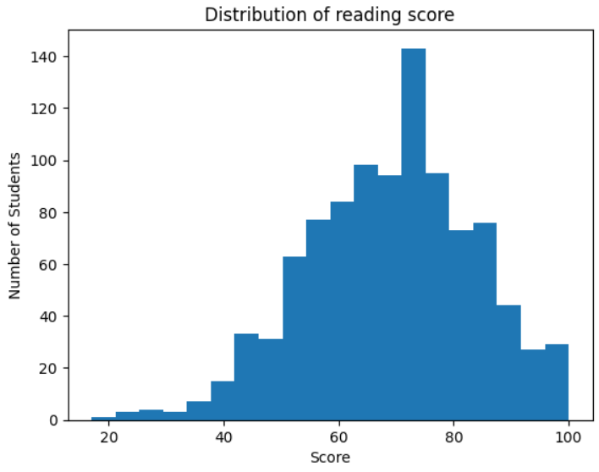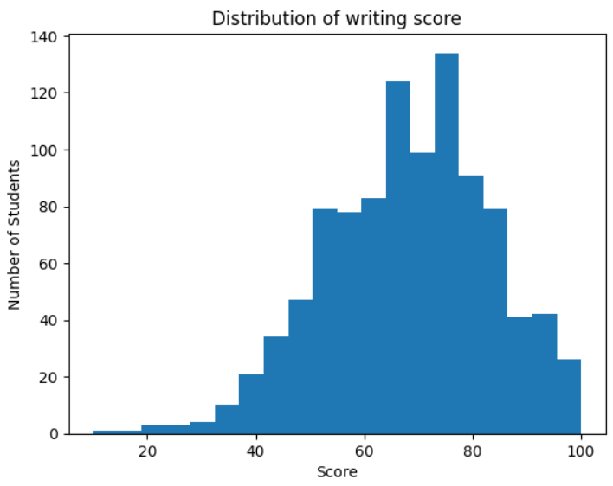

5. RECOMMENDATIONS
• Next analysis steps:
Explore interaction effects (Does test preparation help more for students with lower parental education? Does completing a test preparation course benefit male and female students equally, or does one gender gain more?)
Conduct multivariate regression to understand how gender, parental education, lunch type, and test preparation together impact scores
• Data collection improvements:
Collect additional variables that may influence performance. Include variables: study time per week, attendance records, and school resources such as class size, facilities
• Business implications:
Expand access to test preparation programs and academic support, especially for students from lower socioeconomic backgrounds
Schools and policymakers can monitor score distributions by gender, lunch type, and parental education to identify and reduce achievement gaps

